## Darshan Nikam Date: 12/04/2024

**Kubernetes Tree Tier Project**

1. **Create a DB Instance using the MariaDB Engine and get SSH of the DB Instance over the CloudShell or EC2**

* **Run following command to connect with DB instance**

🡪 mysql -h <endpoint of db-instance> -u admin -p[password]

1. ***Now we create a database for studentapp and then create a student table within it using the following script.***

|  |
| --- |
| ***CREATE DATABASE IF NOT EXISTS studentapp;***  ***USE studentapp;***  ***CREATE TABLE IF NOT EXISTS students (***  ***student_id INT NOT NULL AUTO_INCREMENT,***  ***student_name VARCHAR(100) NOT NULL,***  ***student_addr VARCHAR(100) NOT NULL,***  ***student_age VARCHAR(3) NOT NULL,***  ***student_qual VARCHAR(20) NOT NULL,***  ***student_percent VARCHAR(10) NOT NULL,***  ***student_year_passed VARCHAR(10) NOT NULL,***  ***PRIMARY KEY (student_id)***  ***);*** |

This script will create the "studentapp" database if it doesn't already exist, then switch to that database, and finally create the "students" table within it, with columns for student name, address, age, qualification, percentage, and year passed. Each column has a specified data type and is marked as "NOT NULL", meaning it cannot contain NULL values. The "student_id" column is set as the primary key for the table.

1. ***Now Create the EKS Cluster by following the below steps.***

* ***First Need to create an IAM Role for cluster and node***

1. ***Create Role for EKS Cluster***

* ***Create a Cluster Role by selecting Trusted entity type🡪 AWS service, Use Case 🡪 EKS Cluster, click next***
* ***AmazonEKSClusterPolicy This required permission policy by default added, click next. Enter role name and click on Create role***

1. ***Create Role For Node***

* ***Create a Cluster Role by selecting Trusted entity type🡪 AWS service, Use Case 🡪 Ec2, click next.***
* ***AmazonEC2ContainerRegistryReadOnly, AmazonEKS_CNI_Policy, and AmazonEKSWorkerNodePolicy add these Permission policies in the role, click next, enter the role name, and create the node role.***
* ***Navigate the EKS service in the AWS Console.***
* ***Click on Create Cluster.***
* ***Enter cluster name and select Kubernetes Version.***

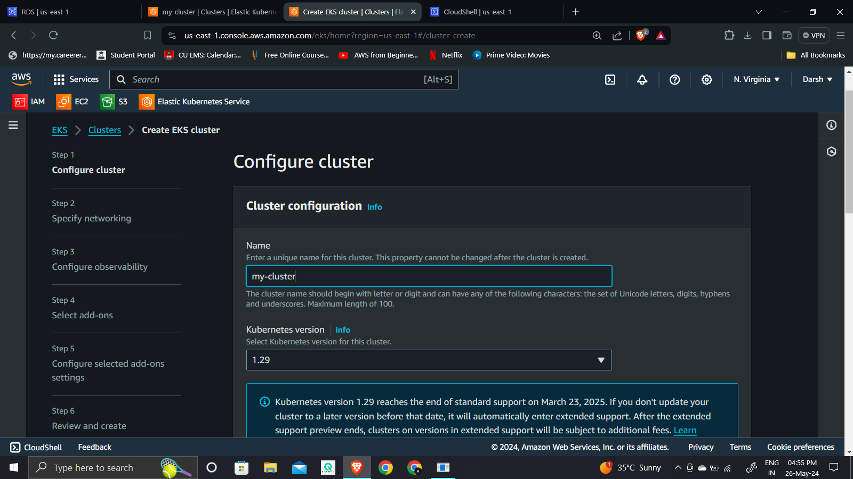

* ***Select the Cluster role that was recently created.***
* ***In the Cluster access option rest as by default.***

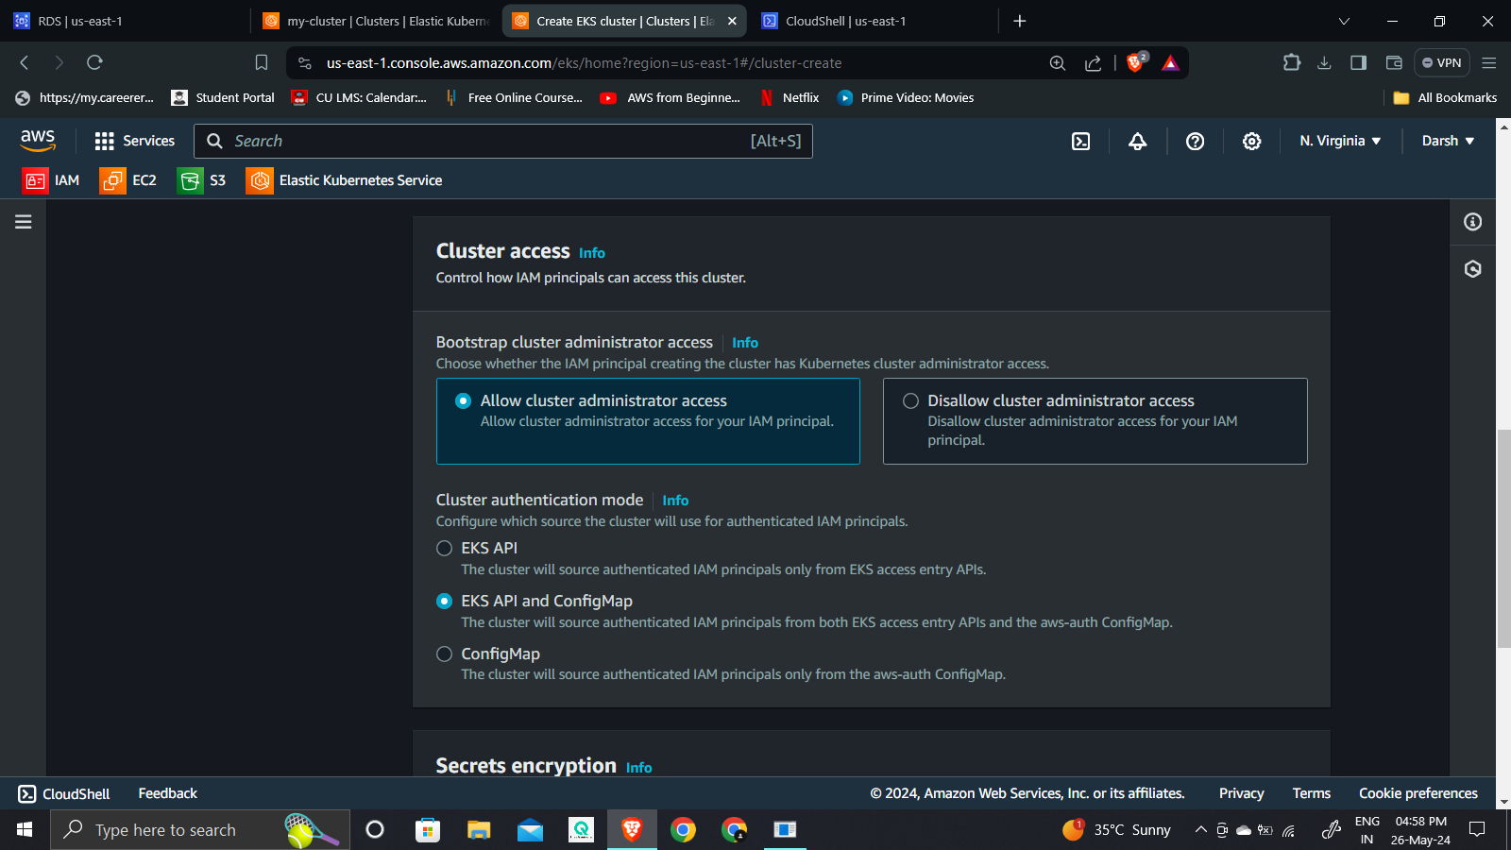

* ***Select VPC and subnets where you want to create your Cluster.***
* ***Select Cluster Endpoint access. By configuring the cluster endpoint access appropriately, you can control whether your Kubernetes API server is accessible from the internet or restricted to internal access only.***

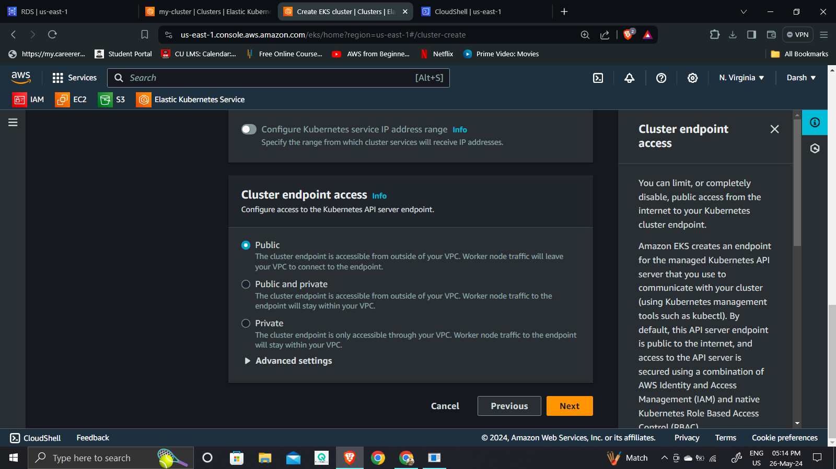

* ***Configuring observability: involves setting up monitoring, logging, and alerting to ensure you can track the performance, health, and security of your system. As per your requirement, you can enable these options***
* ***Select add-ons: Amazon EKS add-ons provide a curated list of operational software with the latest security patches and bug fixes, validated by AWS. Simplifies provisioning a cluster with essential operational tools, ensuring you have secure and updated software to run applications.***

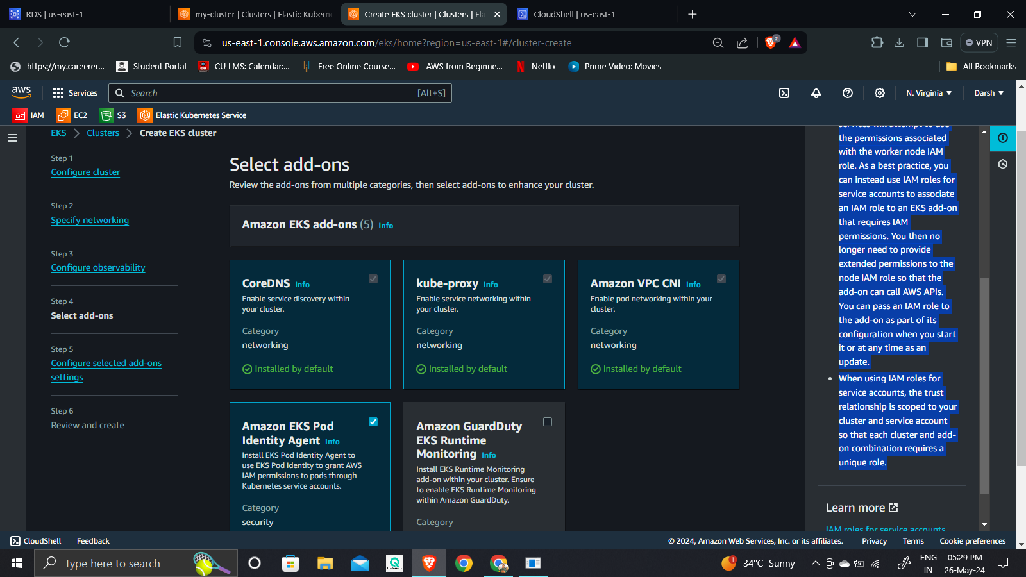

* ***Review all cluster steps, and click on the create cluster button. Usually, it will take 10-15 min to create.***

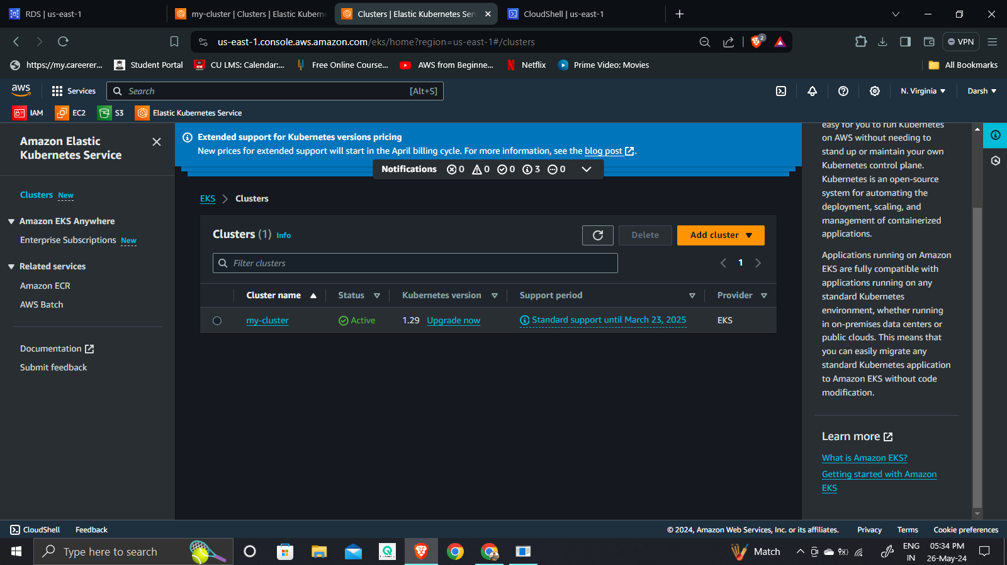

* ***Once the Cluster is active click on the cluster name, to check cluster info and manage it.***
* ***Select the compute option, and click on the Add node group option.***